A000-Eur-Czech Republic-Dolní Věstonice-Figurine-Ursus spelaeus (Cave Bear)-Ceramic-29,000–25,000 BP

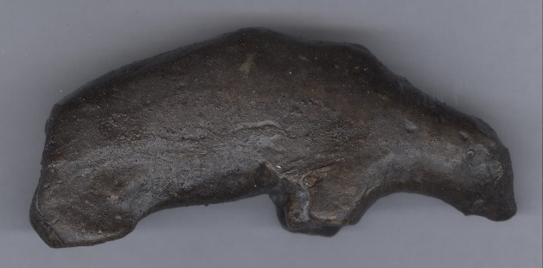

**Fig. 1.** Eur-Czech Republic-Moravia-Figurine-Ursus spelaeus (Cave Bear)-Ceramic-Dolní Věstonice-29,000–25,000 BP, right side**; Fig. 2. Same, left side.**

**Display description: This burnt clay depiction of a cave bear provides the inexperienced hunter with the pose necessary for an approach to the prey. The animal is obviously feeding on the ground and is oblivious to the approaching danger.**

**Accession Number:**

**LC Classification:** GN772.2.A8

**Date or Time Horizon:** 29,000–25,000 BP

**Geographical Area:** Moravia, Czech Republic   
**Cultural Affiliation:** Gravettian industry

**Medium:** fired clay at low temperature, 1300o F, or 700 o C  
**Dimensions:**  H 11.1 cm, 4.4 in: W 4.3 cm, 1.7 in.

**Weight: original, n/a**

**Condition: museum replica in resin.**

Discussion: This figurine, which had not been shattered by thermal shock in the ceramic kiln like most “Venus” figurines at Dolní Věstonice (which has been attributed to removing their potency) may have been unintended.

Dolní Věstonice (ca 28,000 BP to 24,000 BP) is unique in that it has been a particularly abundant source of more than 10,000 purposefully shattered ceramic figurines due to thermal shock when they were placed in a kiln to harden the clay (Vandiver, Soffer and Klima, Svoboda 1989). The remains of two kilns have been uncovered and more than 700 figurines-nearly all depicting Pleistocene animals (such as lions, rhinos, and mammoths) fired in oval earthen kilns. At nearby sites of similar time horizon, thousands more terracotta figurines and clay pellets have been excavated. Almost all the Dolní Věstonice clay was mixed with ash from certain plants that may have had a spiritual significance as a grog.

Ceramic figurines, fragmented or whole (like the present example), recovered from Dolní Věstonice represent the earliest known ceramic technology (Vandiver, Soffer and Klima, Svoboda 1989).

Since ceramics were being produced in order to be shattered via thermal shock, it may be concluded that the *process* of making the objects was more important than the *final* *product*,  *and that this destruction was integral to the reason why they were submitted to being shattered* (Vandiver, Soffer and Klima, Svoboda 1989).  In many cultures (for instance, the Hopi and the Navajo) the act of destroying the integrity of a ceramic piece was considered to be an act of removing the inherent spiritual potency of the object.

References:

Jelinek, J. 1975. *The Pictorial Encyclopedia of the Evolution of Man*. London: Hamlyn

Powers, R. 1994. "The Human Form in Palaeolithic Art," *Modern Geology*, 19(2-4).

Rau, S., D. Naumann, M. Barth, Y. Mühleis, C. Bleckmann. 2009. Eiszeit: Kunst und Kultur. Stuttgart: Thorbecke Verlag der Schwabenverlag AG.

Svoboda, Jiri and Ofer Bar-Yosef. 2003. *Stránská skála : origins of the Upper Paleolithic in the Brno Basin, Moravia, Czech Republic*. Cambridge, MA: Peabody Museum of Archaeology and Ethnology, Harvard University.

Vandiver P, Soffer O, Klima B, Svoboda J. 1989. “The Origins of Ceramic Technology at Dolni Vestonice, Czechoslovakia,” *Science*, 246 (4933):1002-1008.

Velde, B. and I. Druc. 2012. *Archaeological Ceramic Materials: Origin and Utilization*. London: Springer.